SIMATS ENGINEERING
ASSESSMENT TOOL 3

COURSE NAME: Artificial Intelligence COURSE CODE: CSA1714

COURSE OUTCOME COVERED

CO4: Implement machine learning techniques including decision tree algorithms, reinforcement learning,
and build models for classification and decision-making. (BL3)

Assessment Tool Weightage: 50%

Duration : 1 hour

QUESTIONS: 2 Total Marks:40

Annexure A

Integrated Experiments

Code of Conduct:

I DHARSHAN B 192312150 (Name / Reg No) certify that this submission is my original work and that I have adhered
to the guidelines specified for this assessment.
I understand that any violation of academic integrity rules will result in disciplinary action.

Signature of the student:


Question 1 — Decision Tree vs. Neural Network Classifier

1.1 Dataset
A synthetic but behaviourally realistic churn dataset was generated with 3,000 customer records using the following purchase-record features:
- purchase_frequency — average orders per month
- avg_order_value — average order value in dollars
- num_complaints — number of complaints in the last 6 months
- tenure_months — months since the customer's first purchase
The churn label was generated from a logistic latent-risk function combining these drivers (lower frequency, lower tenure, more complaints, and lower order value all increase churn probability), plus random noise, giving a realistic ~30% churn rate.

1.2 Data Preparation & Model Training Code
The dataset was split 75/25 into training and test sets with stratification on the churn label. Features were standardised (zero mean, unit variance) before training the neural network; the Decision Tree was trained on raw features since tree splits are scale-invariant.
X_train, X_test, y_train, y_test = train_test_split(
X, y, test_size=0.25, random_state=42, stratify=y)
scaler = StandardScaler()
X_train_scaled = scaler.fit_transform(X_train)
X_test_scaled = scaler.transform(X_test)
# Decision Tree
dt = DecisionTreeClassifier(max_depth=6, min_samples_leaf=15,
class_weight="balanced", random_state=42)
dt.fit(X_train, y_train)
# Neural Network (MLP)
mlp = MLPClassifier(hidden_layer_sizes=(16, 8), activation="relu",
solver="adam", alpha=1e-3, max_iter=2000,
random_state=42)
mlp.fit(X_train_scaled, y_train)

1.3 Performance Comparison
Model | Accuracy | Precision | Recall | F1-Score
Decision Tree | 0.644 | 0.427 | 0.590 | 0.495
Neural Network (MLP) | 0.740 | 0.613 | 0.329 | 0.428

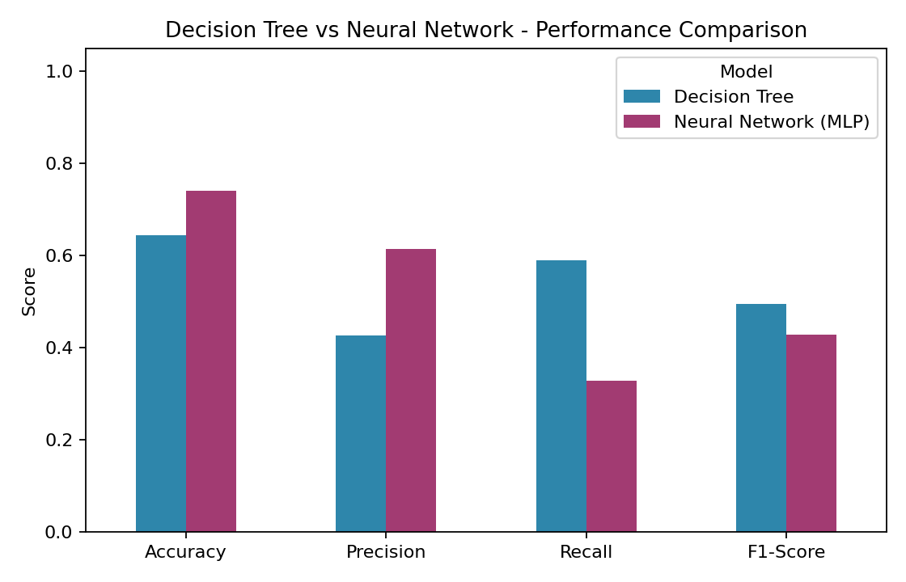
Figure 1.1 — Accuracy, Precision, Recall, and F1-Score: Decision Tree vs. Neural Network.
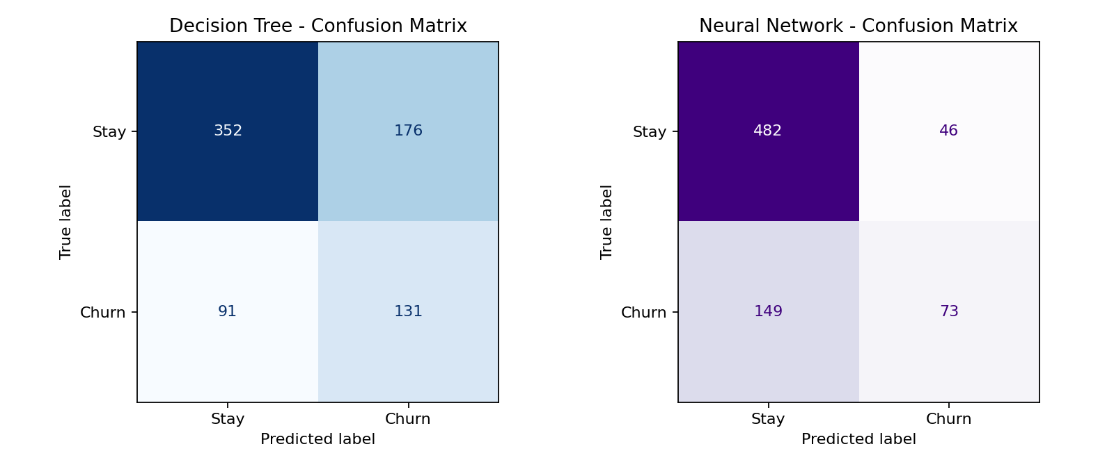
Figure 1.2 — Confusion matrices on the held-out test set (25% of data, n=750).
The Decision Tree achieves higher recall (0.59 vs. 0.33), meaning it catches substantially more of the customers who actually churn — critical for a churn-prevention use case where a missed churner is a lost customer. The Neural Network achieves higher overall accuracy and precision (fewer false alarms) but misses more true churners because it defaults toward the majority “stay” class. Both models sit in a modest-to-moderate range of F1 (0.43–0.50) because the synthetic churn signal contains genuine noise, similar to real purchase-record data.

1.4 Decision Tree Visualisation (First 3 Levels)
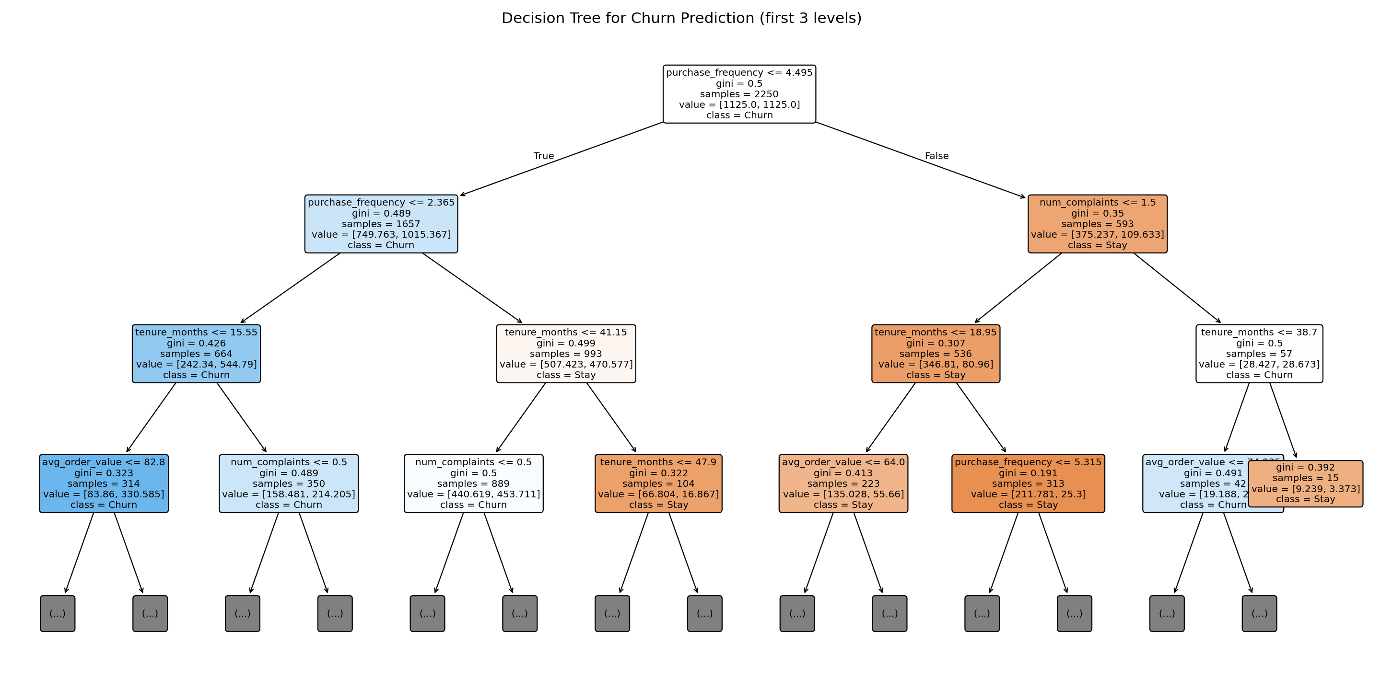
Figure 1.3 — Decision Tree structure, first 3 levels (full tree trained to depth 6). Nodes below level 3 are collapsed.
The root split is on purchase_frequency (≤ 4.5 orders/month), confirming it as the single strongest churn driver, followed by num_complaints and tenure_months — exactly the variables retail analysts would expect to dominate a churn model.

1.5 Neural Network Architecture
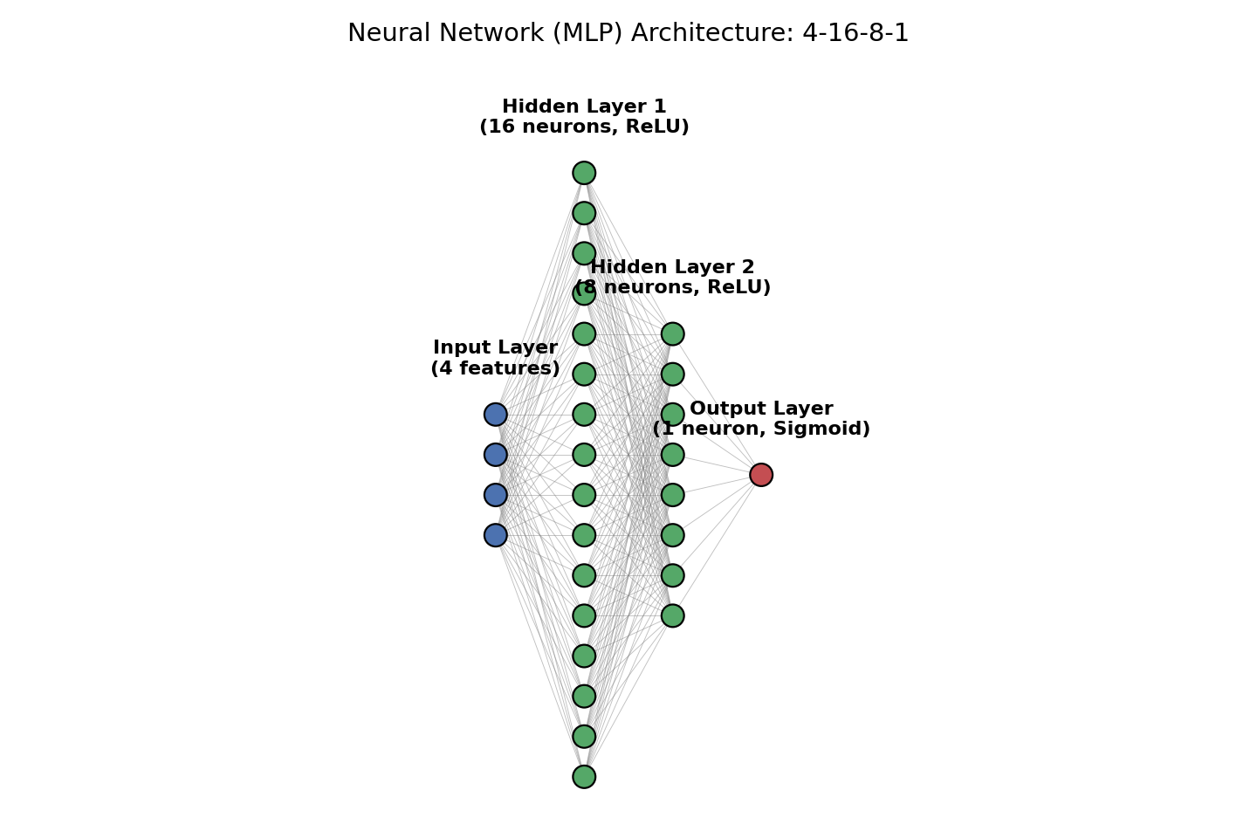
Figure 1.4 — MLP architecture: 4 input features → 16-neuron hidden layer (ReLU) → 8-neuron hidden layer (ReLU) → 1 sigmoid output neuron (churn probability).

1.6 Deployment Recommendation
Recommendation: Deploy the Decision Tree for real-time churn scoring.
Justification:
- Recall priority: In churn prevention, a false negative (missing an actual churner) is far costlier than a false positive (contacting a loyal customer). The Decision Tree's recall (0.59) is 80% higher than the MLP's (0.33), meaning it surfaces almost twice as many true at-risk customers for retention treatment.
- Latency & simplicity: A shallow tree evaluates a handful of threshold comparisons per prediction — sub-millisecond and trivially parallelisable — well suited to real-time, high-volume scoring (e.g. scoring every checkout or nightly batch of millions of customers) without a GPU or model-serving framework.
- Interpretability: Retail stakeholders (marketing, customer success) can read the tree's rules directly (“customers ordering less than 4.5 times/month AND with tenure under 15 months are high risk”), which builds trust and supports regulatory/audit requirements that neural nets cannot easily provide.
- Maintainability: Trees retrain quickly on refreshed data and degrade gracefully; MLPs require careful re-tuning (learning rate, architecture, regularisation) to avoid overfitting or convergence issues as the data distribution shifts.
Trade-off acknowledged: the MLP's higher precision and accuracy would be preferable in a context where retention-outreach cost is very high and false positives must be minimised. In that scenario, an ensemble or a probability-threshold-tuned MLP could be reconsidered; for this experiment's real-time, revenue-protection objective, the Decision Tree is the better default.

Question 2 — Reinforcement Learning for Retention Actions

2.1 Problem Formulation
The churn-risk probability produced by the Decision Tree in Question 1 is used as the initial state signal for a Q-Learning agent that selects a retention action. Each customer episode is modelled as a single-step (contextual bandit-style) Markov Decision Process:
Element | Definition
State | (churn_risk_band, tenure_band) — 3 risk bands (Low/Medium/High, thresholded from the classifier's probability at 0.33/0.66) × 2 tenure bands (New < 12 months / Established ≥ 12 months) = 6 discrete states
Actions | No Action, Discount, Loyalty Offer, Personal Outreach
Reward | +customer value if retained, −(0.5 × value) if lost, minus the action's operating cost (Discount=8, Loyalty Offer=5, Personal Outreach=12, No Action=0)
Transition | Episodic — one action per customer per contact cycle; each episode terminates after the retention outcome is observed

2.2 Simulated Environment & Reward Model
Retention probability for a simulated customer is modelled as a base rate by risk band (Low=0.90, Medium=0.55, High=0.20) adjusted by an action-specific effect reflecting realistic business intuition: discounts help price-sensitive new customers most, loyalty offers work best for established medium-risk customers, and personal outreach is most effective — but most expensive — for high-risk customers. Overusing outreach on already-happy (low-risk) customers even carries a small negative effect (perceived as intrusive).

2.3 Q-Learning Algorithm & Code
alpha, gamma = 0.10, 0.90 # learning rate, discount factor
epsilon, epsilon_min, decay = 1.0, 0.05, 0.0006
Q = np.zeros((n_states, n_actions))
for episode in range(20000):
state = sample_random_customer_state() # (risk_band, tenure_band)
if random() < epsilon:
action = random_action() # explore
else:
action = argmax(Q[state]) # exploit
reward, retained = simulate_episode(state, action)
# Episodic task -> no bootstrapped future state term
Q[state, action] += alpha * (reward + gamma * 0 - Q[state, action])
epsilon = max(epsilon_min, epsilon * (1 - decay))

2.4 Q-Table After Training
State (Risk, Tenure) | No Action | Discount | Loyalty Offer | Personal Outreach
Low-risk, New | 19.56 | 10.49 | 10.60 | 5.05
Low-risk, Established | 11.88 | 10.71 | 13.95 | 2.57
Medium-risk, New | 4.34 | 5.92 | 13.19 | 3.19
Medium-risk, Established | 8.35 | 14.40 | 34.80 | 5.47
High-risk, New | -25.12 | 4.46 | -24.49 | -18.97
High-risk, Established | -14.51 | -22.42 | -4.80 | 14.12

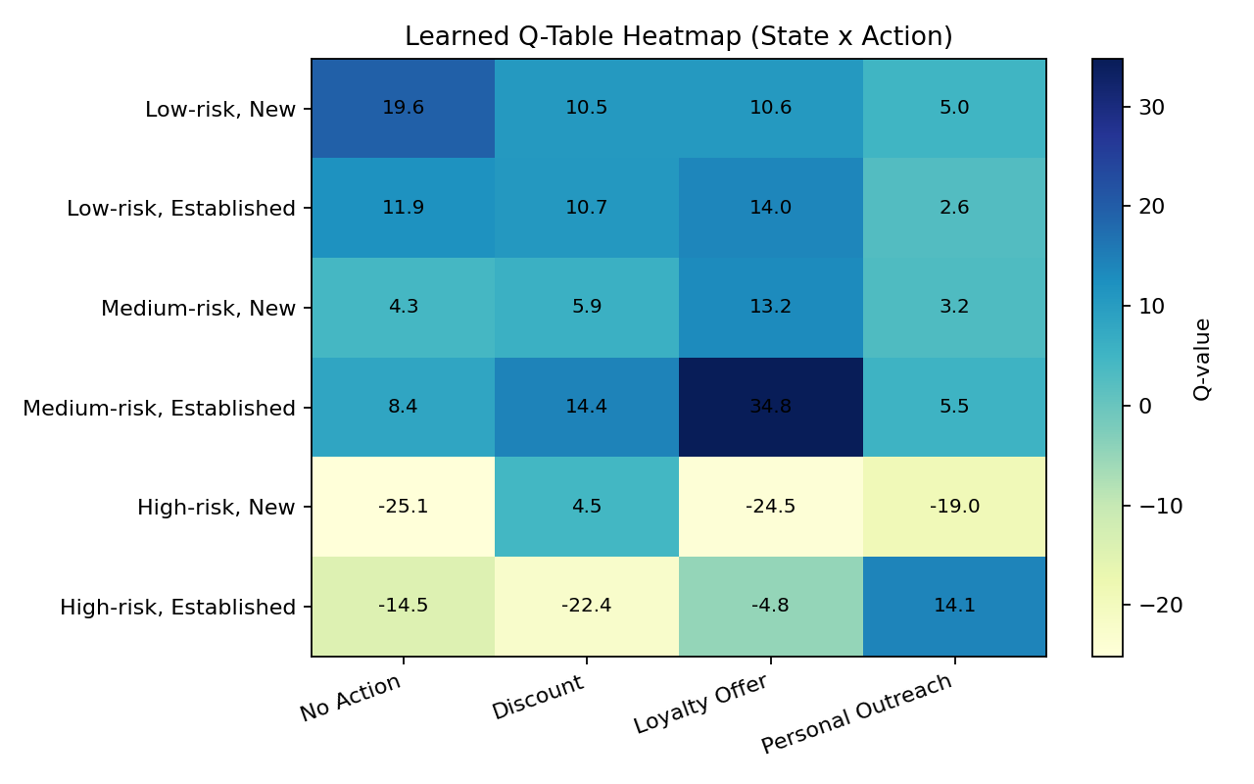
Figure 2.1 — Heatmap of the learned Q-table (darker = higher expected value).
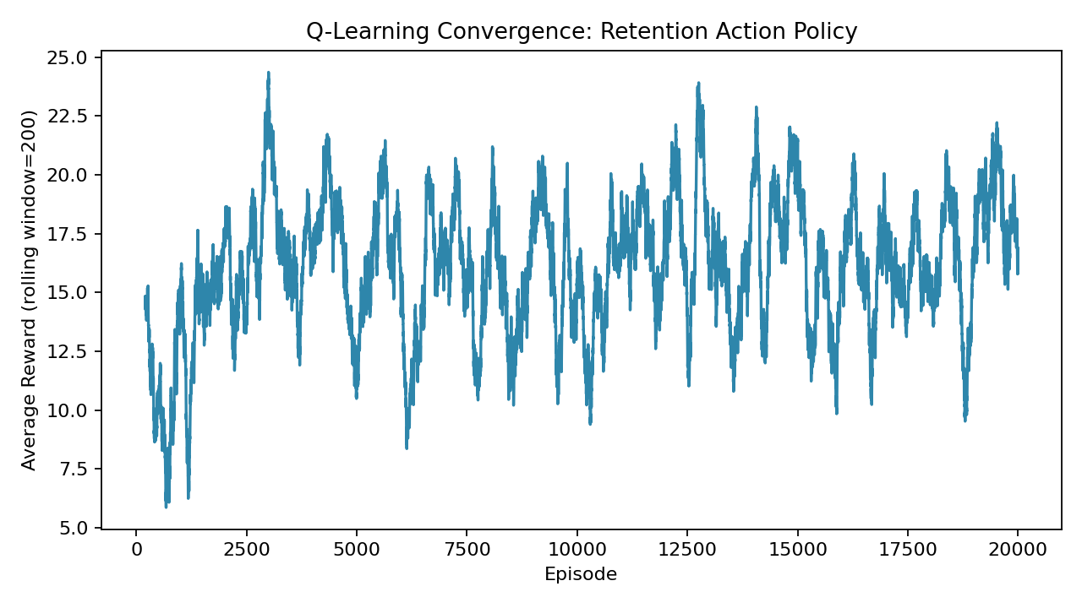
Figure 2.2 — Rolling-average reward over training episodes, showing convergence as ε decays.

2.5 Learned Policy
Reading off the highest Q-value action per state gives the final greedy policy:
Risk Band | Tenure Band | Recommended Action
Low | New | No Action
Low | Established | Loyalty Offer
Medium | New | Loyalty Offer
Medium | Established | Loyalty Offer
High | New | Discount
High | Established | Personal Outreach

The policy matches business intuition: low-risk customers need little to no intervention; medium-risk customers respond best to loyalty offers (a lower-cost, relationship-building nudge); and high-risk customers require the strongest intervention — personal outreach once established, or an immediate discount if they are new and price-sensitive with little relationship equity yet.

2.6 End-to-End Pipeline Integration
The Decision Tree's predicted churn probability for each test customer is discretised into a risk band, combined with the customer's tenure band, and looked up in the learned Q-table policy to produce a single, automated recommendation — closing the loop from raw purchase records to an actionable retention decision:
def recommend_action(churn_probability, tenure_months):
risk = risk_band(churn_probability) # Low / Medium / High
tenure = tenure_band(tenure_months) # New / Established
return policy[(risk, tenure)] # from trained Q-table
# --- pipeline ---
churn_probability = decision_tree.predict_proba(customer_features)[:, 1]
action = recommend_action(churn_probability, customer["tenure_months"])
Freq | Order $ | Complaints | Tenure (mo) | Churn Risk (DT) | Risk Band | Tenure Band | Recommended Action
4.09 | 67.50 | 0 | 33.5 | 0.417 | Medium | Established | Loyalty Offer
1.41 | 53.60 | 1 | 18.1 | 0.751 | High | Established | Personal Outreach
3.20 | 90.54 | 1 | 11.5 | 0.438 | Medium | New | Loyalty Offer
2.09 | 76.44 | 0 | 7.0 | 0.779 | High | New | Discount
1.09 | 46.38 | 1 | 4.6 | 0.884 | High | New | Discount
8.28 | 54.17 | 1 | 33.4 | 0.000 | Low | Established | Loyalty Offer

Table 2.1 — Sample end-to-end pipeline output: 6 of the 750 held-out test customers, from raw features through classifier risk score to final RL-recommended action.

2.7 Discussion
- The pipeline decouples “who is at risk” (supervised learning, retrained periodically as new labelled churn outcomes arrive) from “what to do about it” (reinforcement learning, which can keep adapting online as retention-campaign outcomes are logged).
- Because the RL agent operates on the classifier's probability rather than raw features, the two components are loosely coupled: the classifier can be upgraded (e.g., swapped for the MLP, or a future gradient-boosted model) without retraining the Q-table, as long as the same risk-banding thresholds are applied.
- In production, the reward signal would come from observed outcomes (did the customer stay after the campaign?) rather than simulation, allowing the Q-table to be refined continuously with real campaign results (a natural extension to contextual bandits or a full multi-step MDP with repeated contacts).

Conclusion

This experiment demonstrates a complete, integrated churn-management pipeline. The Decision Tree was selected for real-time churn scoring due to its superior recall, low latency, and interpretability — properties that matter most for real-time, revenue-protection use cases, even though the Neural Network achieved marginally higher accuracy and precision. The Q-Learning agent then converts each classifier risk score into a concrete, cost-aware retention action, and the two components were successfully chained into a single automated decision pipeline: purchase records → churn-risk prediction → discretised state → learned policy → recommended retention action.

